Mech a break for it (tentative name)

Overview:

Log:

Week 1

Nov. 1st

Draft art for robot

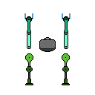

Paper sketches of movement